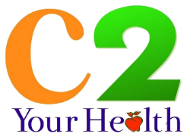
C2 Your Health LLC presents the 28TH ANNUAL report
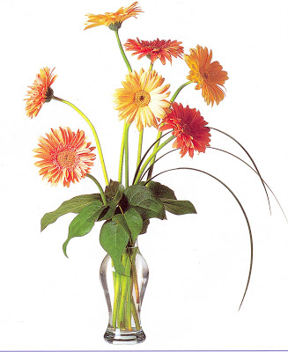
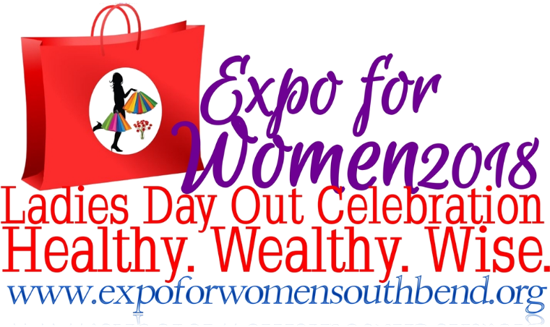
1/1/2016 | 2016 ULTIMATE LADIES DAY OUT CELEBRATION ANNUAL REPORT
 | This is the annual report for the 2016 Expo for Women Ultimate Ladies Day Out held annually at the Century Center Convention Center Downtown South Bend, IN. The Ultimate Ladies Day Celebration is a first-of-its-kind, large scale community event that brings women from all walks of life together in a fun, open environment to discover, shop and support local designers, artists, specialty retailers and area nonprofits. Attendees will treat themselves and their girlfriends to a fabulous day of shopping, food, beverage and product sampling, fashion shows, art, health and wellness demonstrations, rejuvenation services and more.

C2 Your Health LLC presents the 28TH ANNUAL report
2016 ULTIMATE LADIES DAY OUT CELEBRATION ANNUAL REPORT

History of Expo for Women
For 26 years the Expo for Women has been ongoing without interruption with varying degrees of success. During the years preceding 2007 this event experienced declining exhibitor and attendee participation. The promoters of the Expo for Women during these years were WSBT, Healthy Communities Initiative, Women’s Alliance of St. Joseph County and Memorial Health Systems. C2 Your Health LLC was contracted in 2007 as the lead promoter by Healthy Communities Initiative. Beginning 2008 the Expo for Women and the years following the Expo for Women experienced continued growth even during a slowed economy.

Year | # of Exhibitors | Approx. Attendance
2005 | ?
2006 | ?
2007 | 50 | 400
2008 | 134 | 1000
2009 | 111 | 1500
2010 | 100 | 2000
2011 | 122 | 2500
2012 | 134 | 3000
2013 | 157 | 4000

History of Ultimate Ladies Day Out Celebration
The promoters of Expo for Women introduced a new one day event in the fall of 2013 a women only interest event supporting women’s everyday challenges to creating the life they deserve. This event was presented to the Michiana community in the fall (Nov.) 2013 Mishawaka, IN, 2014 South Bend, IN. In 2015 the Century Center requested this women’s event be hosted downtown. The 2016 event is moving to spring downtown South Bend. The goal is to create a smaller more intimate event promoting shopping local encouraging our attendees to support our community with their dollars. The goal is to present a personal more intimate event for women of all walks of life focusing on professional women, stay at home moms and working women, their unique needs specifically health, wellness and beauty.

Year | # of Exhibitors | Year | # of Exhibitors
2013 | 50
2014 | 54 | 2016 | 60 (expected)

Year | Approx. Attendance
2013 | 600
2014 | 1300
2016 | 2000 (expected)

Theme/Goal
The Ultimate Ladies Day Celebration is a first-of-its-kind, large scale community event that brings women from all walks of life together in a fun, open environment to discover, shop and support local designers, artists, specialty retailers and area nonprofits. Attendees will treat themselves and their girlfriends to a fabulous day of shopping, food, beverage and product sampling, fashion shows, art, health and wellness demonstrations, rejuvenation services and more. The theme of Ultimate Ladies Day Out Celebration is “A Day of Beauty Inside and Out.”

Happenings
Hours of Operation: 2 – 8 pm main expo event – 5 – 8 pm Ladies Day Out Happy Hour with cash bar
Location: Century Center Convention Center Downtown South Bend, IN – Discovery Ball Room
Booth Activities: Exhibitors were encouraged to provide demonstrations, play games, have merchandise to sell, set appointments and/or establish a mechanism for future business.
Seminars: Education, workshops, music and dance performances.
Entertainment: DJ entertainment all day, live musicians for Ladies Day Out Happy Hours
Door Prizes: Provided by the exhibitors, sponsors and community donations equal to approximately $10,000 to encourage market survey participation

Advertising Methods
Expo for Women Website: www.expoforwomensouthbend.org
Web directory – exhibitors listed, sponsors logo presented
Internet: Community/event Calendars. Craig’s List, Event Promoters
Engagement: Social media, email marketing, direct mail, internet directory and radio
Community Websites/Banner Ads
Television: ABC News57, WNIT
Radio: B100 Country Radio, WVPE Public Radio
Magazine: Michiana Life, Small Biz Forward
YouTube.com Channel: ExpoForWomenSB – 9 videos

Community Giving
Over the years 10% of the event proceeds goes to community giving plus donated booth space to local smaller charities. These organizations include to American Heart Association BetterU, Hello Gorgeous of Hope, Santa’s Pantry, Hannah’s House, YWCA, Talent’s for Giving, Face Painting, Memorial Foundation, La Casa Amestade, Better World Books, Saint Mary’s Spark WEI program, Girls on the Run, Girl Scouts of America, Paw’s N Purr’s, Saint Joseph Humane Society and Allies for Greyhounds of Michigan.

Sponsorships Opportunities
Thanks to our community sponsors we are able to participate in community giving and help women in need in our community. Over the years the Expo for Women has partnered with Memorial Hospital of South Bend, WSBT, Sunny 101.5, B100 Country Radio, South Bend Tribune, Plastic Surgery Center, Mc Donalds, VPN Marketing Group, ABC 57 News, Swan Lake Golf Club, Kerri's Hair Salon, South Bend Vein Clinic, Juice Plus+ Company, Spotlight Media, Lord Marketing and C2 Your Health LLC.
Sponsor Advertising Package
Value $8,500 package + social media 57,600 impressions

TV Commercials (value $4,000), Public TV Commercials (value $500), Public Radio Spots (value $1,000), Radio Spots (value $3,000), Facebook Ads (6,000 impressions), Google Ads, Direct Mail Marketing (12,000 impressions), Facebook (8 pages, 1,800+ impressions per week, 4,000+ followers), Twitter (4 accounts, 3,000+ followers), Pinterest (475 follower), YouTube Channel (8 videos produced includes 1 video with sponsor exclusive) and Internet Radio Interview (1 interview sponsor exclusive).
Sponsorship Levels
The 2016 Ultimate Ladies Day Out Celebration has three levels of sponsorship.
Bronze: $1000 Silver: $2,000 Gold: $3,000 Swag Bag: $325 shared / $550
(See application for details)

Exhibitor Survey Summary
The total exhibitors were 54 with 60 booth spaces filled (maximum capacity of the Gillespie Center). During the event we checked in frequently with the 54 exhibitors, most reporting they were happy. Following the event we asked the exhibitors to complete an event evaluation to provide feedback for future events. The survey collected stated the exhibitors were happy with the overall event and would consider coming back next year.

Summary of Market Survey
At our 2014 Ultimate Ladies Day Out Celebration of the 989 attendees 286 visitor surveys were collected at admission to the Ladies Day Out – remarkable 29 % return.
How did they hear about the event?
Word of mouth 17%  Fliers 4%  Internet 6% | Website 4%  Radio 13%  TV 29% | Social Media 43%  Magazine 1%  Community Calendar 1%
Who came?
Female – 89 % Male -1.9% No Response – 8.11%

Age of Attendees  18% Under 13  9% Teen  19% College | 26% Young Adult 22 – 35 yrs.  52% Mature Adult 36 – 55 yrs.  19% Seniors 65 yrs. +
Education of Attendees
3% Some HS  31% HS Diploma  5% Trade / Tech  17% Some College | 12% Undergraduate  7% Post Graduate  22% No Response
Household Composite
17% Empty nesters  12% Seniors  15% Single no children  11% Single with children | 10% Couples no children  20% Couples with children  22% No Response
Homeownership – 67.34% of respondents
Household income -
25 – 49 29% | 50 – 74 27% | 75 – 99 22% | 100 -149 15% | 150 – 199 + 7%

Summary
Success!
The introduction of the Ultimate Ladies Day Out Celebration is a growing and thriving exposition type event supporting local business and our Michiana community. Each year the event has experienced a minimum of 10% growth during a woeful “down economy” and was lauded as a wonderful event.

Surveys completed provide statistical data to identify attendee demographics and exhibitor satisfaction. The Ultimate Ladies Day Out Celebration is a successful event with increasing participation, attendance, and enthusiasm, the Expo for Women Ladies Day is poised to build in future years in our growing economy.

Sponsorship offers the possibility of achieving several goals at once. According to Schmander and Jackson in their book, Special Events: Inside and Out, a company can benefit from sponsorship in many ways, such as:
- Enhancing image and Shaping Consumer Attitudes – perception is everything.
- Driving Sales – extremely potent promotional tool
- Creating positive publicity/heightening visibility – wide exposure in print, TV, radio, and electronic media.
- Differentiating from competitors – exclusive sponsorships are a significant way to create competitor differentiation.
- Helping with good “Corporate Citizen” role – viewed as a good neighbor.
- Enhancing business, consumer and VIP relations – hospitality opportunities is always very attractive to companies.

Our community sponsors experienced these benefits along with being instrumental in bringing the very best to women in our community to help them enjoy the benefits of beauty inside and out becoming the best they can be … healthy, wealthy and wise.

Respectfully submitted,

Cindy Cohen RN BS BA
Owner, C2 Your Health LLC
Annual Expo for Women
Ultimate Ladies Day Out Celebration
Event Producer

